Employee ID: 46185397

Name: Rahul Kumar Rajak

**Case Study 8: Create TMG event for validation for the data that is entered in the table**.

**Solution:**

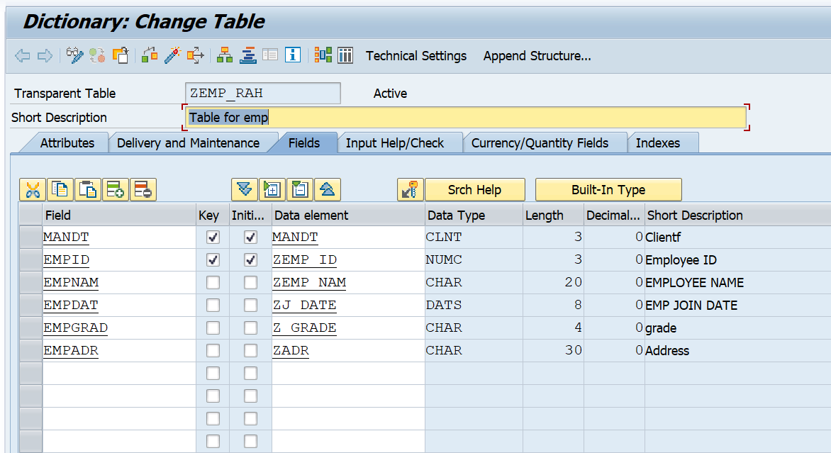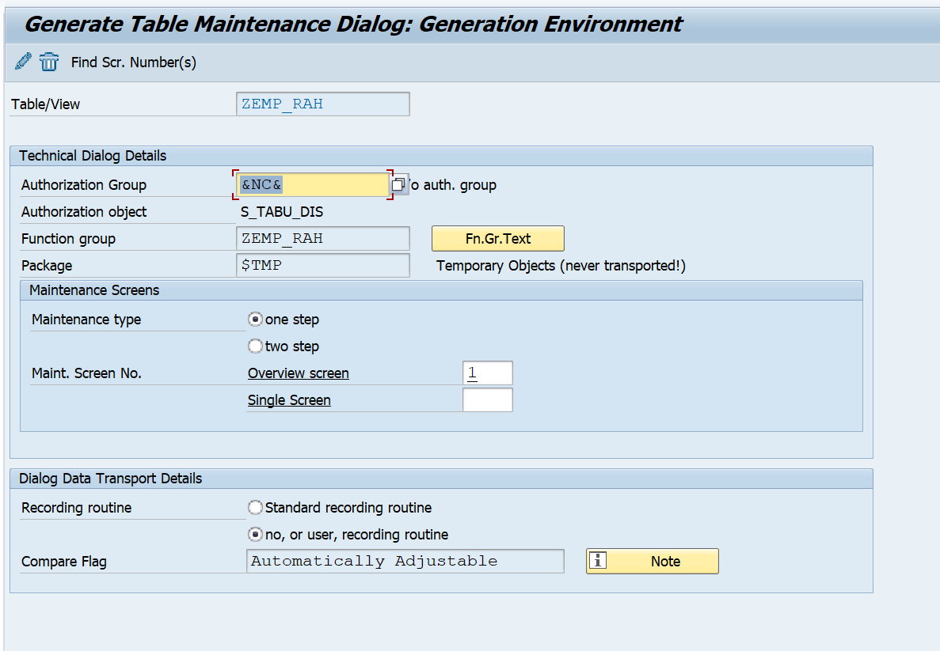**Create a table ZEMP_RAH.**

**Go to table maintenance Generator.**

**Go to Modification and Events.**

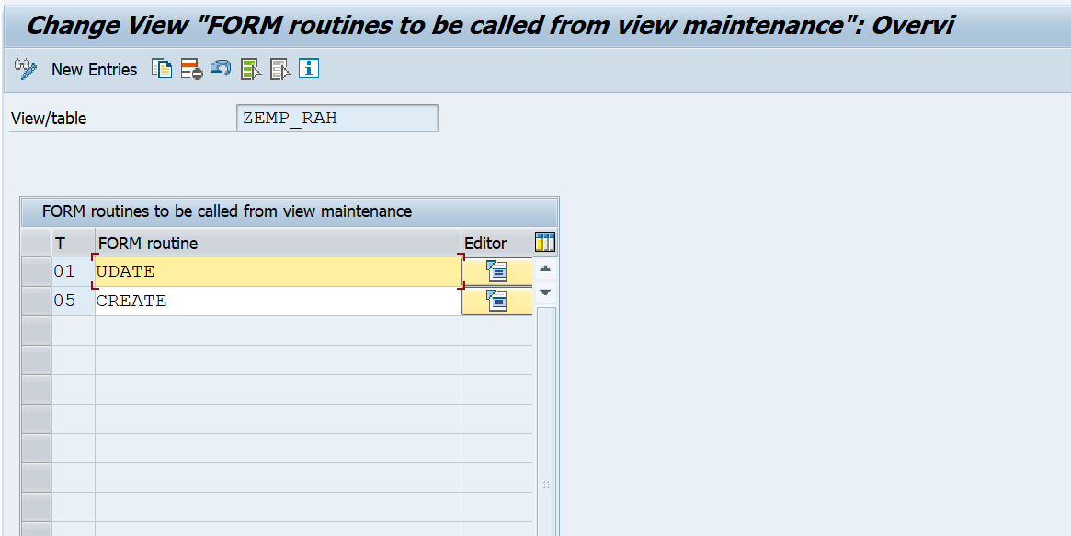

Code in Update Event.

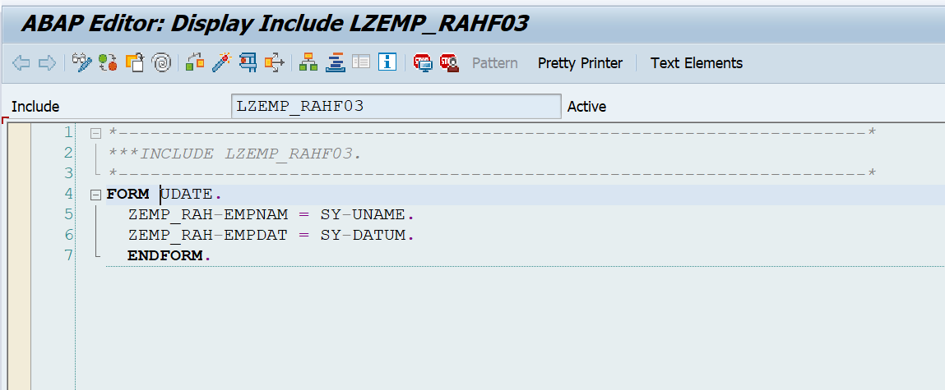

Code in Create Event.

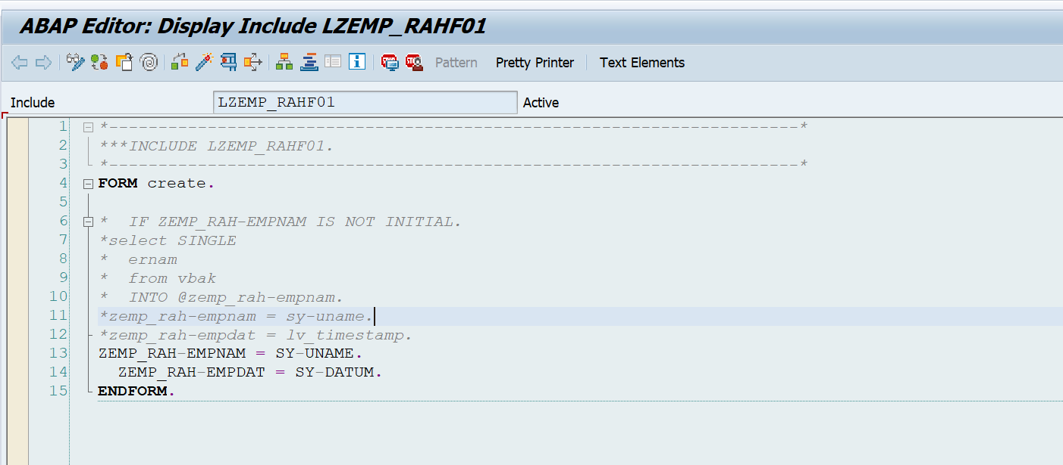

Output :

Fill the data without providing empname and joindate data.

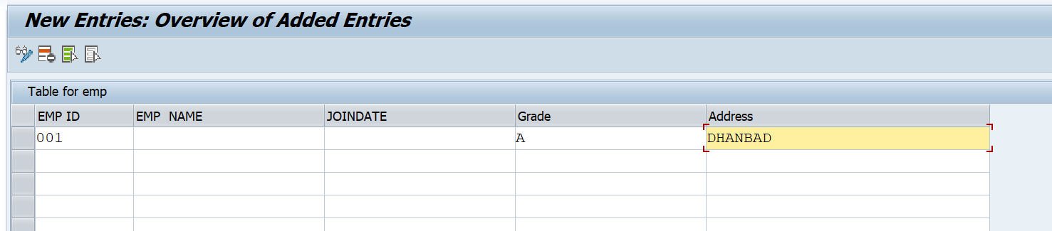

Automaticaly Empnam and joindat comes here.

